Software Requirements Specification Document

Project : Learners Academy
Developer : Jagasabarivel K

Revision History
Date | Version | Description | Author
12/017/22 | <1.0> | SSD 1.0 | Jagasabarivel K

Table of Contents
1. Introduction 4
1.1 Purpose 4
1.2 Scope 4
1.3 References 5
1.4 Overview 5
2. Overall Description 5
3. Specific Requirements 5
3.1 Functionality 5
3.1.1 View Class Report. 6
3.1.2 Register a Student. 6
3.1.3 Register a Class 6
3.1.4 Register a Subject. 6
3.1.5 Register a teacher. 6
3.1.6 Assign or map class, teacher, subject and student. 6
3.2 Usability 6
3.2.1 Graphical User Interface 6
4. Core Concepts Used 7
5. Code Location 7
6. Project Snapshot 7

Software Requirements Specification Document

Introduction

The aim of this document is to gather and analyze and give an in-depth insight of the complete Learners Academy by defining the problem statement in detail. Nevertheless, it also concentrates on the capabilities required by stakeholders and their needs while defining high-level product features. The detailed requirements of the Learners Academy are provided in this document.

Purpose

The purpose of the document is to collect and analyze all assorted ideas that have come up to define the system, its requirements with respect to consumers. Also, we shall predict and sort out how we hope this product will be used in order to gain a better understanding of the project, outline concepts that may be developed later, and document ideas that are being considered, but may be discarded as the product develops.

In short, the purpose of this Software Specification document is to provide a detailed overview of our software product, its parameters and goals. This document describes the project's target audience and its user interface, hardware and software requirements. It defines how our client, team and audience see the product and its functionality. Nonetheless, it helps any designer and developer to assist in software delivery lifecycle (SDLC) processes.

Scope

Primarily, the scope pertains to the file manager product features for making Learners Academy live. It focuses on the company, the stakeholders and applications, which is a school that has an online management system. The system keeps track of its classes, subjects, students, and teachers. It has a back-office application with a single administrator login.

This Software Specification is also aimed at specifying requirements of software to be developed but it can also be applied to assist in the selection of in-house and commercial software products. The standard can be used to create software requirements specifications directly or can be used as a model for defining a organization or project specific standard. It does not identify any specific method, nomenclature or tool for preparing an Software Specification.

References
The references are:

- Class room training from simplilearn.com

Overview

The remaining sections of this document provide a general description, including characteristics of the users of this project, the product's hardware, and the functional and data requirements of the product. General description of the project is discussed in section 2 of this document. Section 3 gives the functional requirements, data requirements and constraints and assumptions made while designing the administration application. It also gives the user viewpoint of product. Section 3 also gives the specific requirements of the product. Section 3 also discusses the external interface requirements and gives detailed description of functional requirements. Section 4 is for supporting information.

Overall Description

This document contains the problem statement that the current system is facing which is hampering the growth opportunities of the company. It further contains a list of the stakeholders and users of the proposed solution. It also illustrates the needs and wants of the stakeholders that were identified in the brainstorming exercise as part of the requirements workshop. It further lists and briefly describes the major features and a brief description of each of the proposed system.

The following SRS contains the detail product perspective from different stakeholders. It provides the detail product functions of file manager with user characteristics permitted constraints, assumptions and dependencies and requirements subsets.

Specific Requirements

The specific requirements are –

Functionality

Introduction –

This subsection contains the requirements for the school management system. These requirements are organized by the features discussed in the vision document. Features from vision documents are then refined into use case diagrams and to sequence diagram to best capture the functional requirements of the system. All these functional requirements can be traced using tractability matrix.

View Class Report.

The system shall display view a Class Report which will show all the information about the class, such as the list of students, subjects, and teachers.

Register a Student.

The system shall allow administrator to register a student in the school.

Register a Class

The system shall allow administrator to register a class in the school.

Register a Subject.

The system shall allow administrator to register a subject in the school.

Register a teacher.

The system shall allow administrator to register a teacher in the school.

Assign or map class, teacher, subject and student.

The system shall allow administrator to assign or map class, teacher, subject and student.

Usability

Graphical User Interface

- Registration - Administrator needs to register with the registration screen to login and use the application.
- Login – Administrator will be prompted with login screen for authentication in order to use the application.
- Home/Index Page – This will have three option for the Administrator to choose from.
Add Details - Map the class, subject, teacher and student. Note: This also has the submenu to register new subject, class, teacher and student.
Show Class Details – This will display the class report of all the classes in the school.
Show Class Details – This will allow use to search a student record with student name as the input.
- Logout – This will log out the Administrator.

Core Concepts Used
- OOPS
- Servlet
- Jsp
- Hibernate
- Mvn
- Git

Code Location
https://github.com/JAGASABARIVEL/Java/tree/master/Back%20End

Project Snapshot

Registration Screen

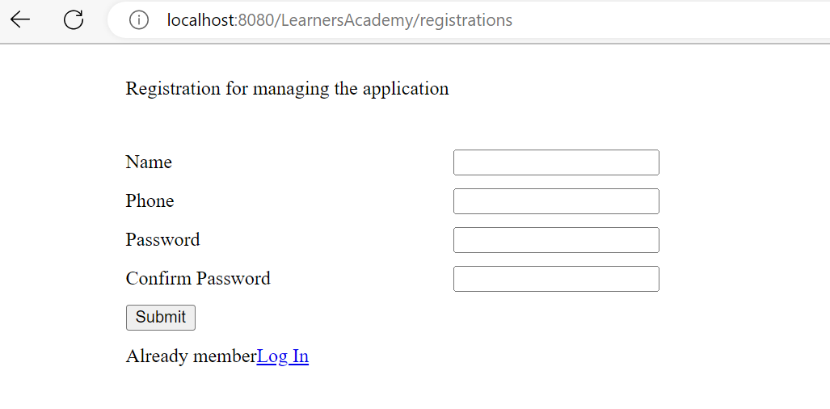

Login Screen

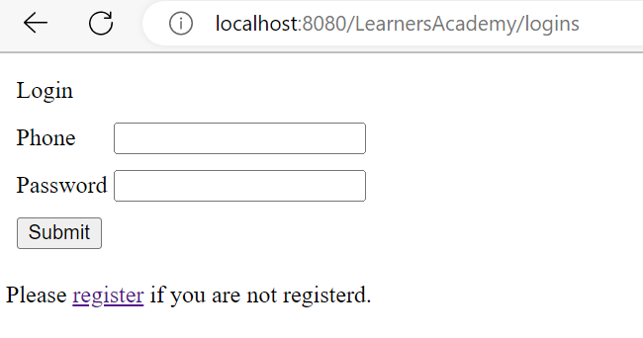
Home Screen
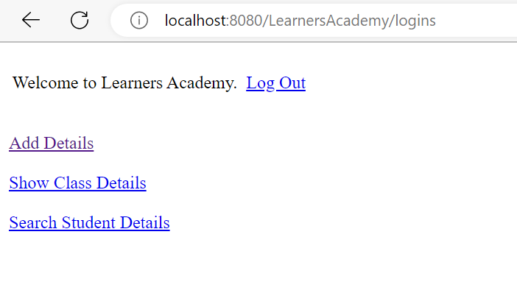
Add Details Screen
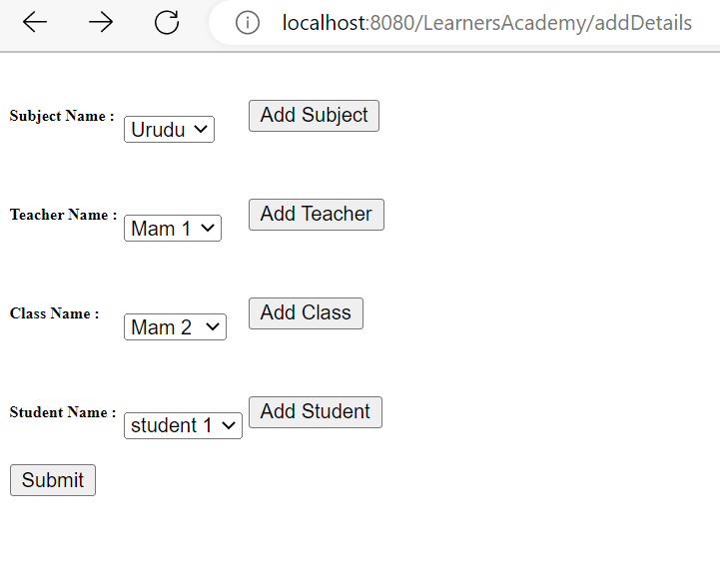

Class Details Screen
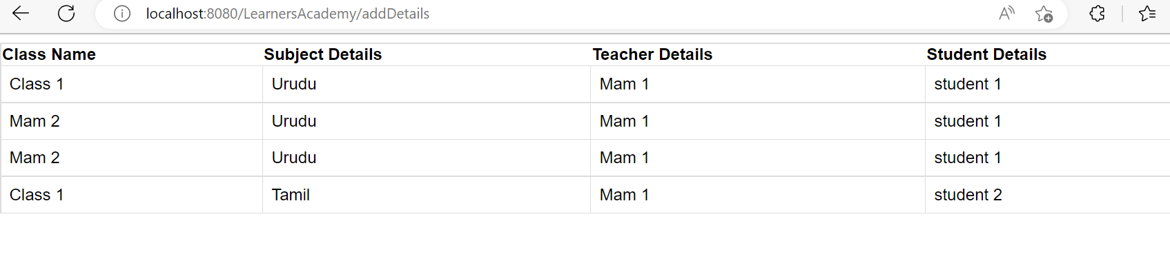
Search Student Scree